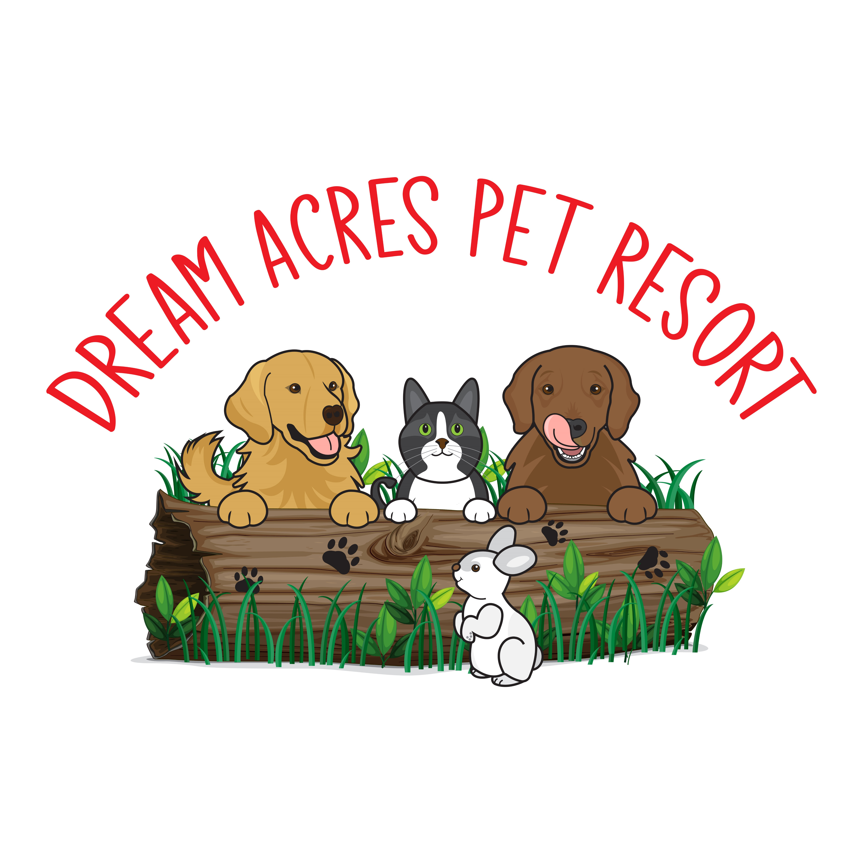

CAT CARE AGREEMENT

At Dream Acres Pet Resort, you receive the kind of quality and service you expect from a top-notch hotel. We baby our feline guests and make sure they enjoy their stay and look forward to returning. You can be rest assured that your kitty will enjoy their vacation as much as you would. Each day the litter, water, food and rooms are cleaned. We provide bowls, toys, treats, cat posts and other furniture; however, we suggest you bring a favorite something for your feline friend to make them feel even more "at home". We use Costco Kirkland brand clumping Litter. If your cat prefers a different brand, we ask that you bring a supply.

**Vaccinations**

Proof of vaccination is required before your pets are checked in. This is to ensure your pet will enjoy a disease-free environment. This includes Feline Viral Rhinotracheitis, Calicivirus, Panleukopenia (3-in-1) and Rabies. Feline Leukemia vaccination is recommended, and the cat's owner assumes all risk to his cat(s) and other animals under the contractor's care, if the cat(s) are not vaccinated for feline leukemia.

**Please note**: We do accept titer tests in lieu of vaccinations as long as your cat has had at least one prior vaccination in their lifetime.

For elderly, or vaccine-reactive cats; we do accept a letter of good health from your veterinarian as long as it is dated within a month of boarding.

WE DO NOT ACCEPT FIV POSITIVE CATS.

**Medications**

If your cat is on oral medication or drops, we charge a nominal fee of $2.50/day. Please let us know in advance of any medical requirements your cat might have.

Full Payment is required for bookings over peak periods (Christmas, New Years, March Break, and Easter). There is an additional $8.00 Holiday fee charged for Christmas Day, Boxing Day, New Year’s Day, Family Day, Good Friday, Victoria Day, July 1st, August Civic Holiday, Labour Day and Thanksgiving Day. Payment is by Cheque or e-transfer and should be done prior to or at the time of pick-up. A $45 charge will be applied for NSF cheques.

I have read and understand the terms and conditions of my cats stay.

Signature___________________________ Date: ________________________