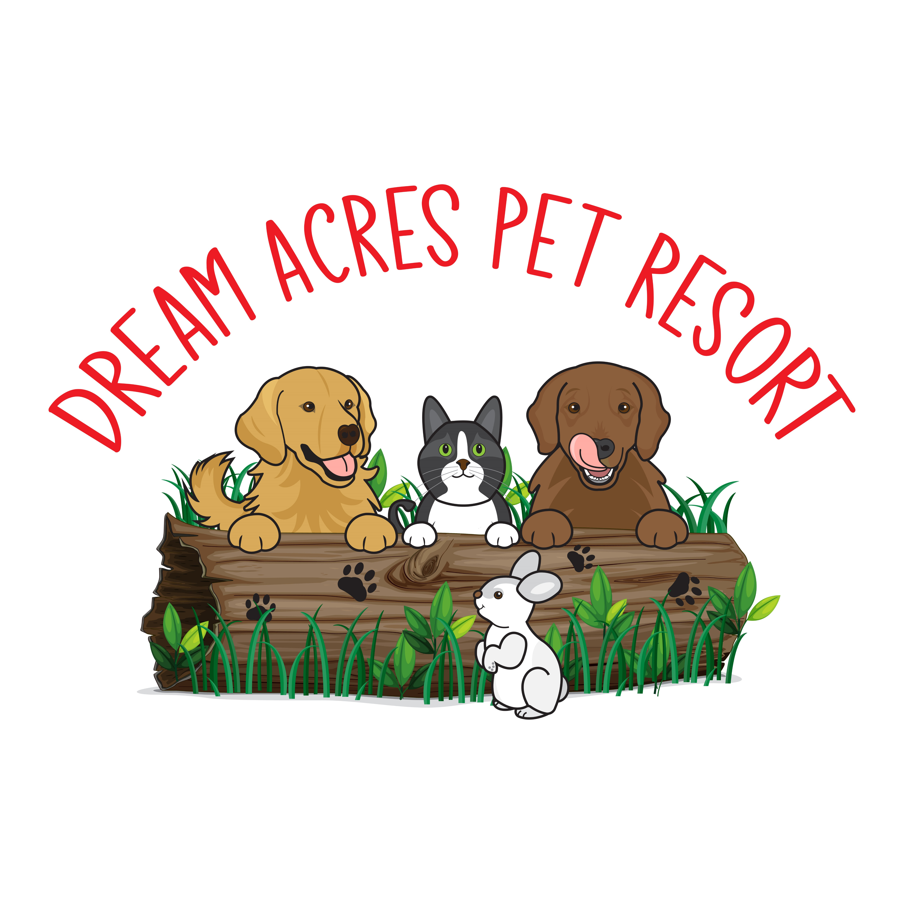

INSTRUCTION SHEET

Please bring enough food for your dogs booked stay plus an additional 2 days, in case your return home is delayed.

Food dishes and water buckets are provided by us. If your dog requires a busy bowl we do have those as well.

If you wish to bring treats please do so!

We have raised beds and blankets available for bedding but we recommend bringing a blanket, towel or t-shirt that smells of home. Please understand that your dog may not chew their bedding at home but may do so while staying at the resort. Therefore, we cannot guarantee your items will return home undamaged. Large beds are not accepted as they do not fit on our raised cots.

Please bring your dog from your vehicle into the office on leash. We do live on a busy road so it is safer for all to have your dog secure.

We are an off leash resort and go out with a large group of dogs.

We are closed statutory holidays for arrivals and departures. Therefore, for example, drop off for Christmas would be no later than 12:00 pm Christmas Eve day (Dec 24th) and the resort is closed to departures on Boxing Day, Dec 26th).

We do not request specific vaccines as some dogs have severe allergic reactions or due to age/medical conditions. We will respect you and your veterinarian’s decision for what is best for your dog, that you are aware that other owners may do the same, and that your dog’s risk is the same as walking in public spaces.

We require a payment of 100% of the boarding invoice for peak times such as Christmas, New Years, March break, Victoria Day, July 1st, August Civic Holiday, Labour Day and Thanksgiving.

Payment is required at pick up time. Cash, etransfers or cheque (made out to Dream Acres Pet Resort) are accepted. A charge of $45.00 will be applied for an NSF payment.

WE LOOK FORWARD TO YOUR DOGS VISIT WITH US.