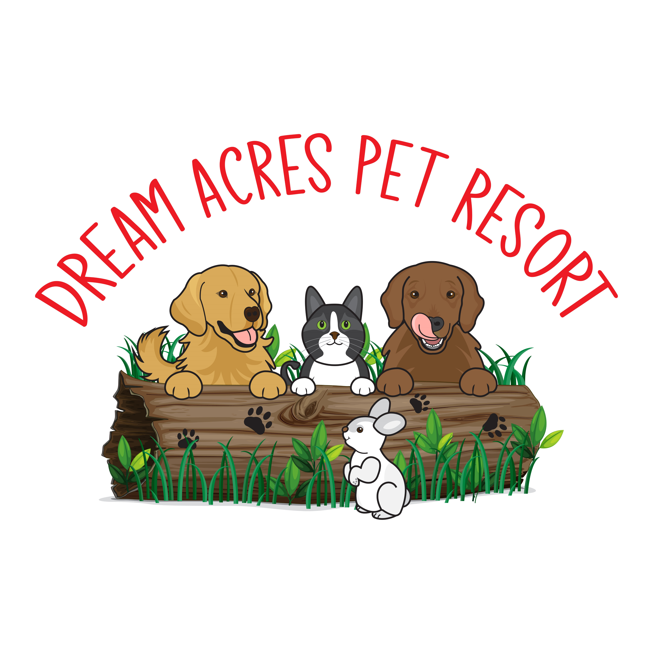

SMALL ANIMAL CARE AGREEMENT

At Dream Acres Pet Resort, your pet receives the kind of quality care and service you expect from a top-notch hotel. We make sure our small animal guests enjoy their stay and look forward to returning. You can be rest assured that your pet will enjoy their vacation as much as you would.

Each day, the litter, water, food and rooms are cleaned. Special cuddle time is always included!

We provide sleeping boxes/hutch/crates, bowls, toys, treats, litter and litter boxes (recycled newspaper pellets); however, we do suggest you bring a favorite something for your pet to make them feel even more "at home". We ask that you provide all food necessary for your pets stay with us.

**Medications**

If your pet is on oral medication, we charge a nominal fee of $2.50/day. Please let us know in advance of any medical requirements your pet may have.

A deposit is required for bookings over peak periods (Christmas, New Years, March Break, and Easter). There is an additional $8.00 Holiday fee charged for Christmas Day, New Year’s Day, Good Friday, Victoria Day, July 1st, August Civic Holiday and Thanksgiving Day.

Payment is by e-transfer or cheque and should be done prior to or at the time of pick-up. A $45 charge will be applied for NSF cheques.

I have read and understand the terms and conditions of my pets stay.

Signature___________________________­­________ Date: ________________________