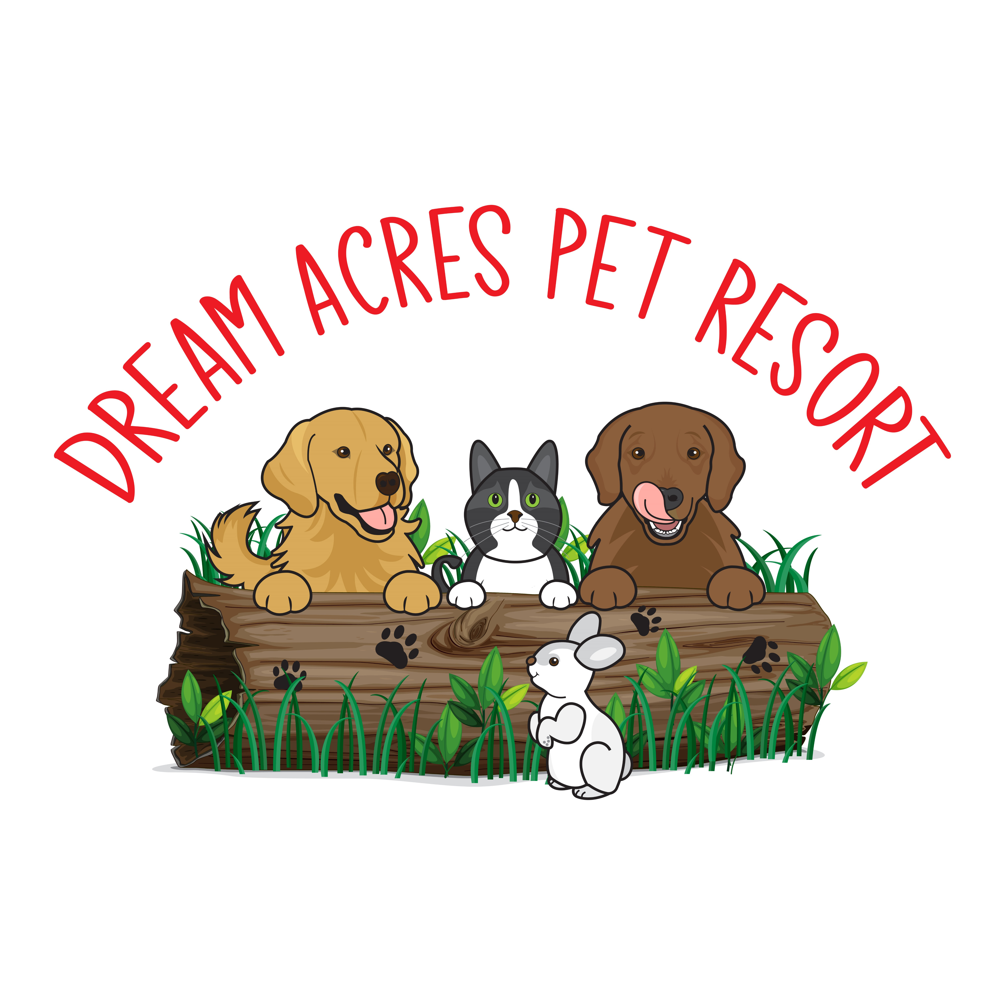

CARE AGREEMENT

Welcome to Dream Acres Pet Resort!

We promise to feed your dog(s) according to their regular schedule, with the food you have provided.

We will exercise by playing in our field, playground and water play area, both morning and afternoons. Weather permitting, we will be outside for 2-3 hours in the morning and then again in the afternoon.

Our guests will sleep in their private, secure runs in the kennel area at night. All precautions are in place to provide a safe and happy stay. Cameras are installed in the kennel building to alert the owners to any temperature changes, alarms or activity after lights out.

With outdoor play, your dog(s) may return home dirtier than when they arrived! The resort staff will give muddy dogs a rinse before lights out and before pick up. All guests go to bed dry and have clean bedding.

Full Payment is required for bookings over peak periods (Christmas, New Years, March Break, Easter, July 1st, August Civic Holiday, Labour Day, Thanksgiving).

There is an additional $10.00 Holiday fee charged for Christmas Day, Boxing Day, New Year’s Day, Family Day, Good Friday, Victoria Day, July 1st, August Civic Holiday, Labour Day and Thanksgiving Day.

Changes in length of stay may be made 48 hours prior to drop off with no surcharges. Early departures, without 48 hours notice, are subject to fees. We try to be flexible about pick up days but please understand that your dog’s run maybe booked for another guest.

Payment is by Cash, Cheque or e-transfer and should be done prior to or at the time of pick-up. A $60.00 charge will be applied for NSF cheques. I have read and understand the terms and conditions of my dogs stay.

Signature___________________________ Date: ________________________