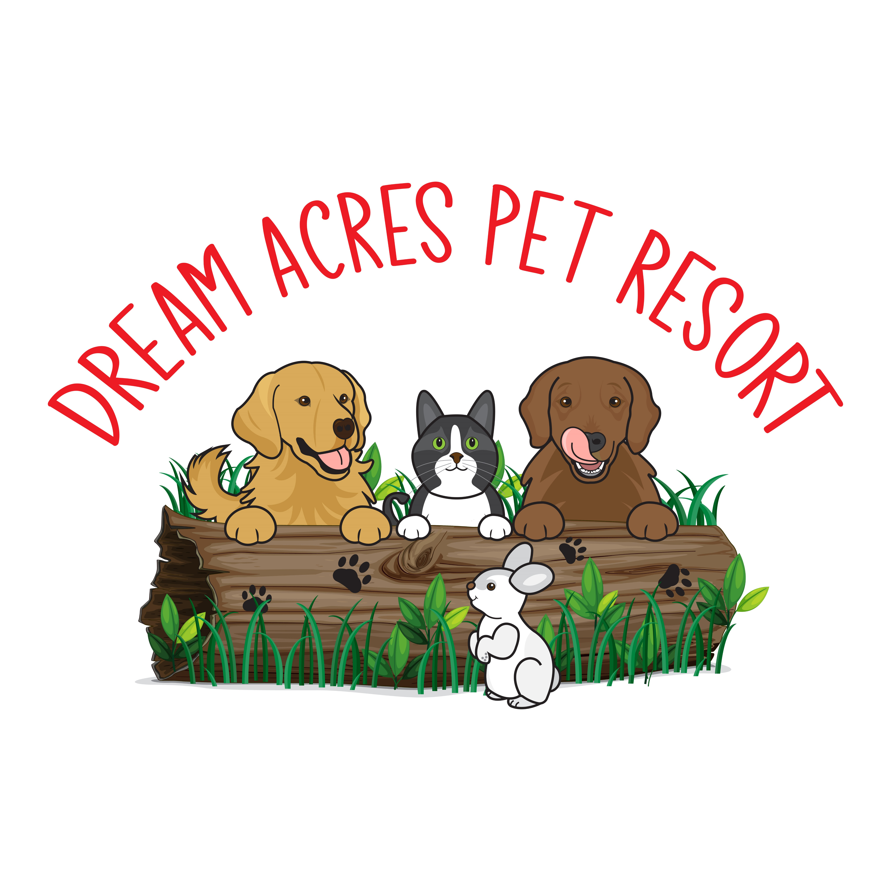

**Waiver and Daycare/Boarding Agreement**

I understand that my dog will be cared for according to my instructions and to the agreement outlined below:

I accept that injuries may happen when dogs play together. Teeth may catch on fur or ears during play. Rough play happens. I understand that the resort staff are trained and attentive to dog play and interactions, but sometimes accidents do happen.

I know the staff will do everything in their power to care for our dogs(s). I also understand that every measure has been taken to ensure the safety of the dogs in your care and that the staff will not be held responsible for any injury due to accidental situations.

I understand that if it is determined that my dog requires veterinary care the staff will try to contact myself or my emergency contact and will attempt to take my dog to our veterinary clinic. If that vet is unavailable, then the staff will transport our dog to a local vet known by Dream Acres Pet Resort.

I will be responsible for that expense and give my veterinarian permission to treat my dog to a maximum amount of $_____________. ($500.00 is a recommended amount) Initial_______.

I understand that Dream Acres Pet Resort is not liable for any unexpected, illnesses which are not directly linked to the care being given to our dog during its stay. I accept that staff will initially treat tummy upsets with pure pumpkin or slippery elm for diarrhea (unless we have allergy information on file for our dog).

During our dog’s stay, if another dog becomes ill while in your care, the staff will inform us so that we are aware of possible symptoms to watch for.

We at Dream Acres Pet Resort do everything possible to prevent the spread of disease. We disinfect all runs daily, dishes are washed after every meal and water buckets are replaced daily. An air purifier operates in the kennel at all times. Occasionally dogs may go home with diarrhea from the increased exercise and excitement. They should be fine after a couple of days at home. They will most likely sleep more than usual for a day or two. All staff are certified in Animal First Aid.

I do not hold Dream Acres Pet Resort responsible for any lost, broken or damaged personal items (toys, beds, etc.) left in our possession during our dog’s stay. Initial ___________.